Trike system
High level organization is given in the block diagram
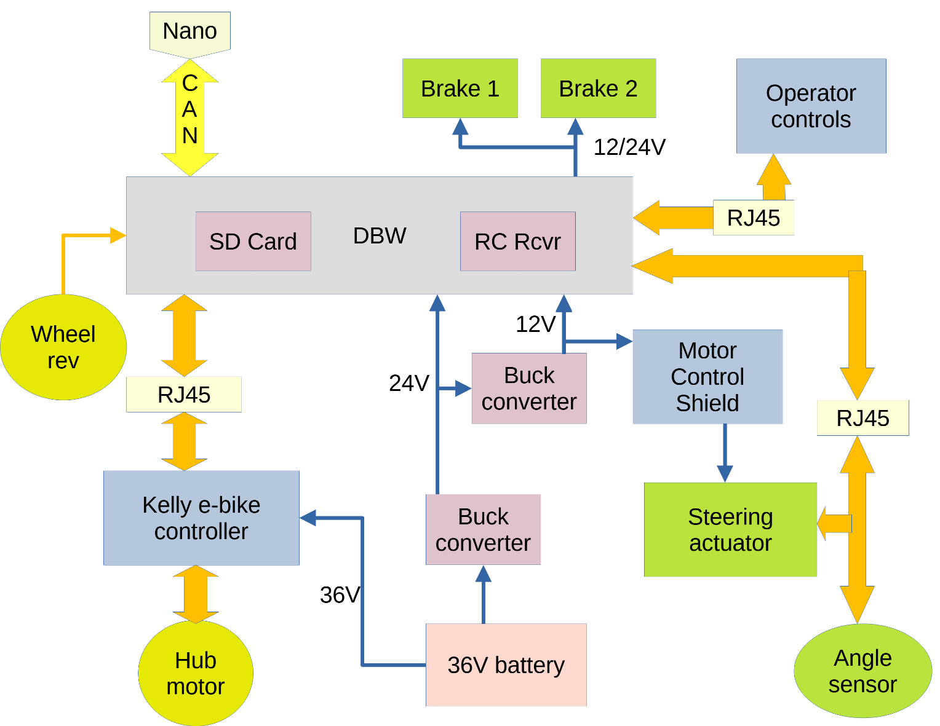
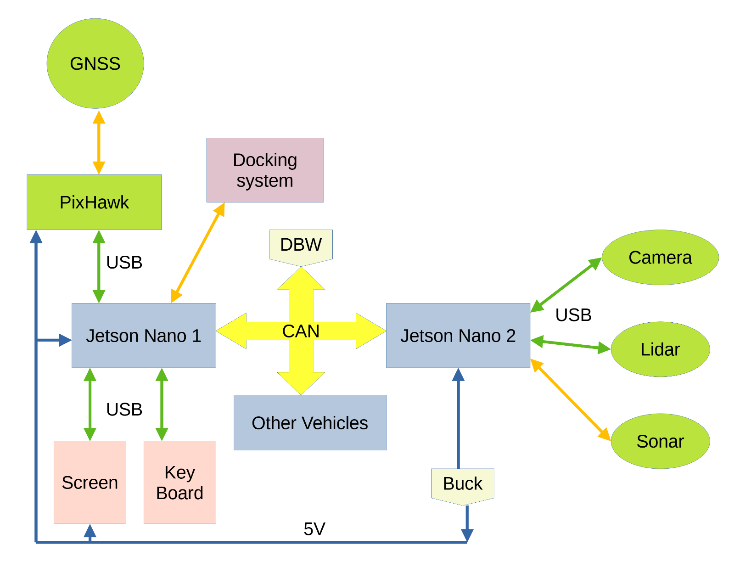
The steering system can be either a linear servo or a linear actuator. The servo is more expensive, and often fails. Students attempted to build an H-bridge system for the actuator, but it is unreliable. We purchased three new linear servos in September 2025, but only one of them worked. It turns out that the Arduino Motor Controller shield with an external 12V supply can power the actuator, and that is now the preferred approach. The servo can run on 12-24V. We use the12V, supply. Steering can be done in any of three ways:
- Send a Pulse Width signal on D48: 1.5 ms for straight; 1.0 or 2.0 ms for hard right or left turn. Uses RJ45 pin 6.
- Send a binary R_Turn/L_Turn on D48 and D41 to the H-Bridge board. Servo extends on 10, retracts on 01, and stays as is on 00 or 11. Uses RJ45 pins 6 and 7.
- Use motor controller shield with D12 selecting right/left; D9 selecting whether motor moves; D3 setting motor speed and A0 giving current draw. Does not use RJ45.
An angle sensor gives feedback on the wheel angle. There may be sensors on either or both of the left and right steering columns. The analog signal is subject to noise; it may be supplemented or replaced by a digital sensor. There are three possible configurations for the sensor:
- Analog sensors read an input and ground. Both wires could acquire noise on their way to the Due. A chip on the DBW board subtracts the ground from the return to reduce noise. May use RJ45 pins 1,2,3 and 4.
- SPI digital sensor uses MISO, MOSI, SCK and CS on RJ45 pins 1,2,3 and 4.
- CAN digital sensor uses CANHI and CANLO. Does not use RJ45.
Signals to the actuator and sensor are:
 | Steering end |  | DBW End
RJ45 Pin | V5A | V5B | V5A Pin (DUE) | V5B Pin (DUE)
1 | L_ANG | MISO | (A10) - in | MISO - in
2 | L_RTN | ANG CS | (A10) - in | D39 - out
3 | R_ANG | SCK | (A11) - in | SCK - in
4 | R_RTN | MOSI | (A11) – in | MOSI - out
5 | GND | GND | NC | NC
6 | PWM | R_TURN | D48 - out | D48 - out
7 | NC | L_TURN | D41 - out | D41 - out
8 | 5V | 5V | NC | NC

Ground and 5V for the angle sensors comes from the steering servo, not the Arduino. Signals in parenthesis require additional processing before going to the Due. The angle sensor pins subtract out the return signal.
Throttle signals must be converted between 3.3 and 5 volts. Throttle control is handled by the Kelly e-bike controller. It must receive the 36V signal from the switch to turn on the controller. Its signals are:
RJ45 Pin | Signal | Due Pin | Kelly pin | Kelly wire color
1 | REV/FWD | (D36) | M12 | White
2 | Current meter | (A9) | F8 | Dark blue
3 | Brake | (DAC 1) | F2 | White
4 | BRK_SW (Regen) | (D43) | F13 | Brown
5 | Spare | (D24)
6 | Throttle | (DAC 0) | F3 | Dark green
7 | Speedometer | (D22) | 17 Hall B | Green
8 | EBIKE alive | (D45) | F4 or M11 | Purple or Dark grey
 | 36V |  | M7 | Pink

Speed is computed from a reed switch that produces an interrupt once per wheel revolution. A more accurate speed could be obtained from the Hall Phase signal with several pulses per revolution. This system has not been implemented. A third possibility would be a sensor on the axle that measures shaft rotation speed.
The trike can operate as a remote-control vehicle, via the RC unit. It can operate autonomously from a command from the Jetson Nano giving the speed and steering angle to reach the next waypoint. For computing paths, turn radius may be easier to implement than using wheel angle directly. A path segment can be specified by the reciprocal of the turning angle and the distance to travel on the segment. Going straight has an infinite turn angle; the reciprocal is 0. The Jetson Nano will need to take the route between waypoints and convert it into straight segments and circular arcs. The DBW software will have the task of setting the wheel angle to match a desired turn radius.

